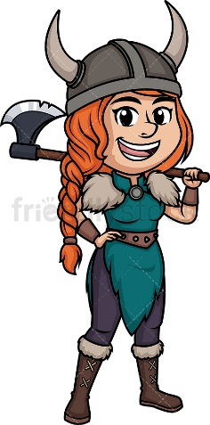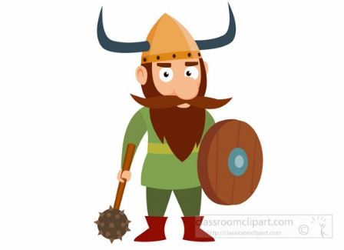 

VIKING Dress-up Day

On Friday 22nd January year 6 are invited to come dressed as a Viking. Please see attached sheet with ideas for simple costumes using items you already have.

Y6 Creative Homework

**Vikings**

**Choose one activity to complete at home.**

**Hand in by Friday 22nd January.**

|  |  |
| --- | --- |
| Create a Viking artifact- you could make a shield, helmet, jewellery or a weapon. | Create a Viking longship that floats on the water |
| Research and present work about a theme on the Vikings Eg, Viking Gods, Northern lights, Viking warriors | Write an exciting Viking saga.  Write a non-chronological report about Viking life |