Well done for a great first week back to all of the pupils who joined us last week.
Please use these ideas to do extra work from home.
If you are still home learning make sure that you send in examples of your work to admin@broadbentfold.tameside.sch.uk so I can see what you’re up to.
Literacy and Communication | 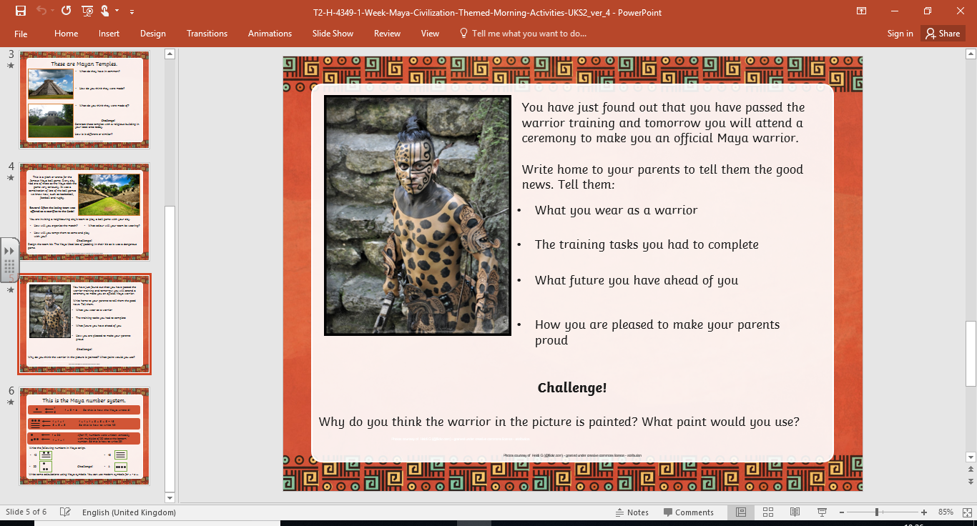  Writing  Look at the attached activity-Mayan warrior. Describe what you would be like as a Mayan warrior. What would you wear? What tasks would you have to complete?  SPAG  Complete the SPAG activity mat.  Spelling frame: suffix- ‘fer’  https://spellingframe.co.uk/spelling-rule/36/43-Adding-suffixes-beginning-with-vowel-letters-to-words-ending-in-fer
Maths and Problem Solving | Look at the information about ratio: https://www.bbc.co.uk/bitesize/topics/zsq7hyc/articles/z8kfnbk  Look at the attached ratio problems- choose the level that you feel comfortable with and have a go.  Mymaths.co.uk: complete- ratio introduction and proportion introduction.
Science and the outside environment | 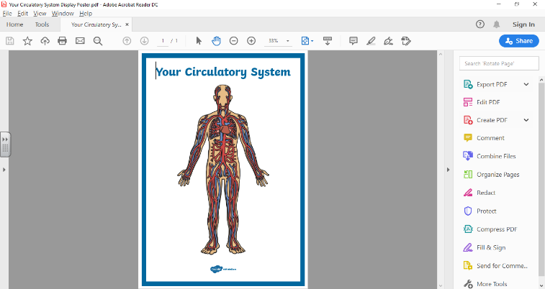  Watch the clips and find out information about the circulatory system:  https://www.bbc.co.uk/bitesize/topics/zwdr6yc  Download the attached information about the circulatory system and answer the comprehension questions.
Creative Arts | Use the following link to inspire you to create your own Mayan temple:  https://www.youtube.com/watch?v=tOfZRZStY18  Can you create a temple using other materials eg lego, stones/pebbles, play-do, clay.  Remember to take a picture and send it to the admin email.
Computing | https://www.thinkuknow.co.uk/parents/Support-tools/home-activity-worksheets/8-10s/?utm_source=Thinkuknow&utm_campaign=e9ea1fa21d-TUK_ONLINE_SAFETY_AT_HOME_19_05_20&utm_medium=email&utm_term=0_0b54505554-e9ea1fa21d-64734522  Complete some of the 15 minute activities about online safety.
Physical Education | Look at the lockdown PE challenge: how many can you complete this week? Try and set a challenge of completing at least one activity per day.
Humanities and Citizenship | Look at the clip:  https://www.bbc.co.uk/bitesize/topics/zq6svcw/articles/z2gkk2p  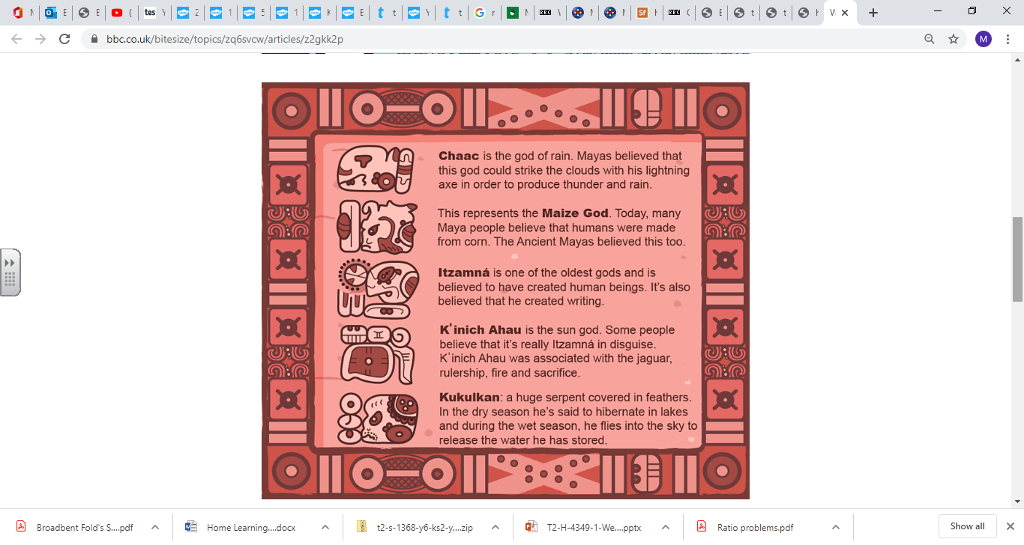  Use this to help you design your own Mayan god- use the attached sheet as a guide.
Reading | Reading:  Download the attached document: ‘Maya creation reading comprehension’.  Read the information and answer the questions.  Please log on to bug club instead of having a class reading book this is what we use for now.  Use https://readtheory.org/auth/login to practise some comprehension work.
Times tables | Do not forget to continue to practise your timetables. Spend 10 minutes a day at least on TT Rockstars. https://ttrockstars.com/  https://mathsframe.co.uk/en/resources/resource/486/Y6-Arithmetic-Practice

