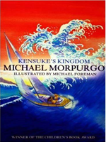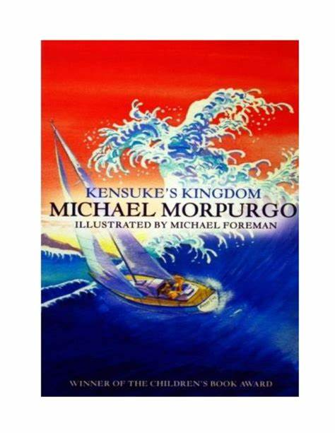

**As Sports People we can…**

Follow a sequence in dance

Develop hockey skills

**Reading Text Links are…**

**Kensuke’s Kingdom by Michael Morpurgo**

**As Religious Observers / Model Citizen we can**

* Identify people who care for us and know their roles
* Know how families can be different
* Respect ourselves and others.

**Would you survive?**

**Hooks for learning:**

**Kensuke’s Kingdom**

**Island making**

**The arrival of a mysterious box**

**As Mathematicians we will…**

* Understand about multiples and factors
* Use consistent methods to multiply and divide
* Measure weight, length, volume, capacity, area and perimeter

**As Scientists we can…**-Know about and explain the movement of the Earth and other planets relative to the Sun

-Know about and explain the movement of the Moon relative to the Earth

-Know and demonstrate how night and day are created

-Describe the Sun, Earth and Moon (using the term spherical)

**As Artists/ Musicians / Designers we can…**

* Design, make and evaluate a deserted island.
* Painting The Wave in the style of Hokusai

**As Geographers / Historian we can…**

* Know the names of a number of European capitals
* Know the names of, and locate, a number of South or North American countries
* Know how to use graphs to record features such as temperature or rainfall across the world

**As Readers and Writers we can…**

* Write diaries, as a ship’s log
* Write metaphorical poems related to the sea and imaginary related to waves
* Write an adventure story
* Become fluent at reading Kensuke’s Kingdom.
* Explore the text and retrieve information from it.
* Summarise and predict events throughout the story.

**As Linguists we can speak in sentences using:**

* Vocabulary related to streets, shops and cafes.

**As Computer Users we can…**

Develop a program that has specific variables identified