Dear Parents, Carers
I do hope that you are all keeping safe and staying well. Please find attached the home learning for Friday 20th November to Wednesday 25th November. If your child completes any work, please post it on Seesaw, where I aim to review it daily. Further zoom links will be sent to you via School Ping on a daily basis.
If you have any issues, worries or concerns, do not hesitate to contact admin@broadbentfold.tameside.sch.uk
I look forward to seeing you back at school on Thursday 26th November.
Kind regards
Ms McCoy.
Literacy and Communication | https://www.bbc.co.uk/bitesize/topics/zvwwxnb/articles/ztcp97h  Please continue to use the bitesize link to practice your spellings, punctuation and grammar.  This week focus on how to use inverted commas. We will be going through this on Monday’s zoom session.
Maths and Problem Solving | Please complete the maths booklet:  file://25.46.140.162/Public/Planning/Y5/2020%202021/Autumn%202/Maths/x%20%2010/Y5-HL-Autumn-Block-4-Multiplication-and-division-1-2020%20(1).pdf  If you’re struggling with some aspects of the booklet, follow the link below to watch some guidance videos.  https://whiterosemaths.com/homelearning/year-5/week-10-number-multiplication-division/  Continue to practise:  Use the attached website to practise for at least 30 minutes a day. See if you can win the Maths World Cup!  http://www.math-exercises-for-kids.com/learning-math-8.htm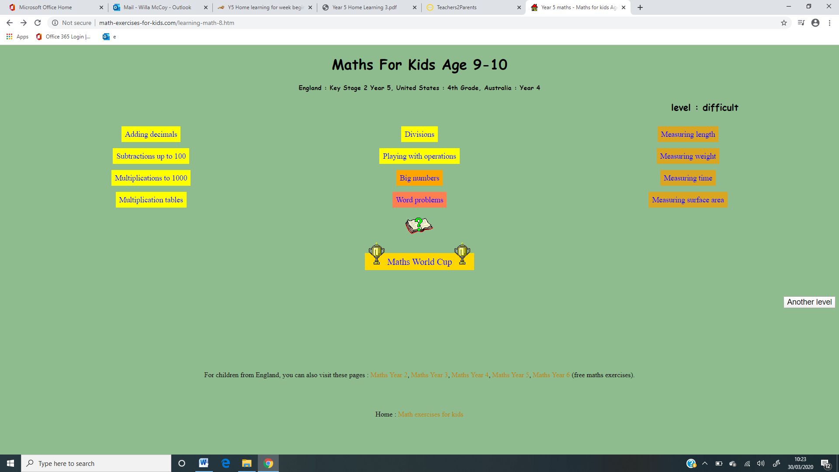
Do not forget to continue to practise your timetables. Spend 10 minutes a day at least on TT Rockstars. https://ttrockstars.com/

Year 5 children need to know all their times tables.
If you’re at the stage for a test- use this link to help test your knowledge. http://www.timestables.me.uk/
We will be going through the White Rose maths questions in our Tuesday’s zoom session.

Topic | 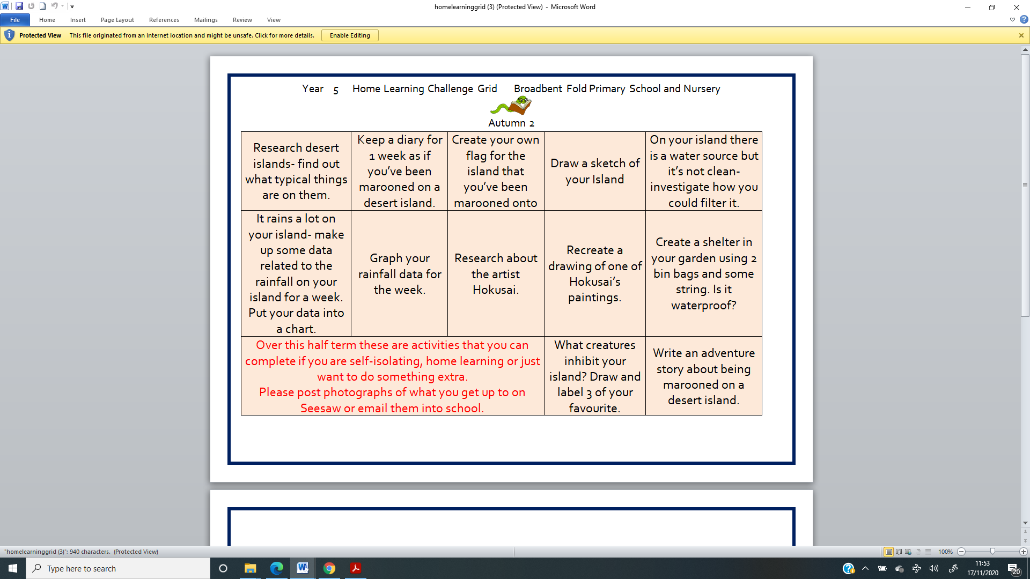  It’s time to investigate Islands. Have a look at the activities below and use your imagination. Enjoy We will showcase these in Wednesday’s zoom session  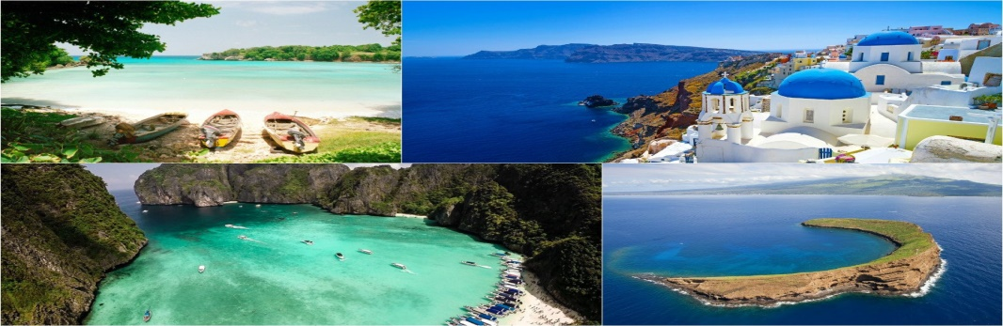
Science Topic | All about the moon.  Watch the attached videos and write about the moon.  Try and include:  - What is it  - How is it seen  - Why does it change shape  - Why can it be seen during the day  - What at the 8 phases of the moon  - A picture that includes the 8 phases of the moon  Cycles of the moon  https://www.youtube.com/watch?v=f4ZHdzl6ZWg  https://www.youtube.com/watch?v=NCweccNOaqo  https://www.youtube.com/watch?v=sEQB0_3nvCA  Use the attached moon sheet to plot a picture of the moon at night over the next week.  We will be showcasing this in Wednesday’s zoom session
Humanities and Citizenship | Watch Newsround and stay up to date with the latest news for children. If you have any questions about Newsround, please ask an adult. https://www.bbc.co.uk/newsround/news/watch_newsround.  Try out this geography scavenger hunt if you didn’t get chance to do it last week. https://digimapforschools.edina.ac.uk/resources/scavengerhunt/
Physical Education | Dance, move and exercise.  It is so important to be active, even when you’re in the house so make sure you get chance to play in your garden. If you haven’t completed this challenge already, give it a go  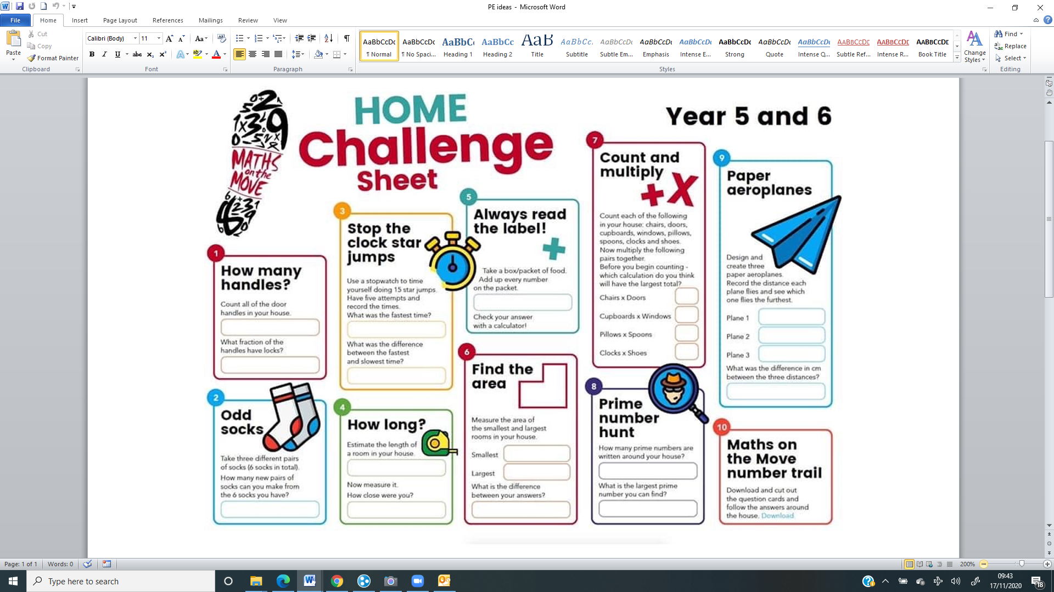 | Other skills:  - Throw and catch (against a wall or to a partner)  - Football skills  - Skipping
Reading | Reading- aim for 30 minutes a day  - Use the new EPIC link and complete some reading quizzes.  https://www.getepic.com/app/profile-select  Class Code: ieb2643 | Try and keep a list of the books you read, we could see who reads the most. Try and read a different Michael Morpurgo book.

